Project Design Phase-II
Technology Stack (Architecture & Stack)
Date | 5 September 2026
Team ID / Project ID | SWUID2026190359
Project Name | Metro Ticket Generating System in ServiceNow
Maximum Marks | 4 Marks

Technical Architecture:
The architecture represents the main application logic, ServiceNow platform components, data storage, user interface and external QR-code service used by the Metro Ticket Generating System.
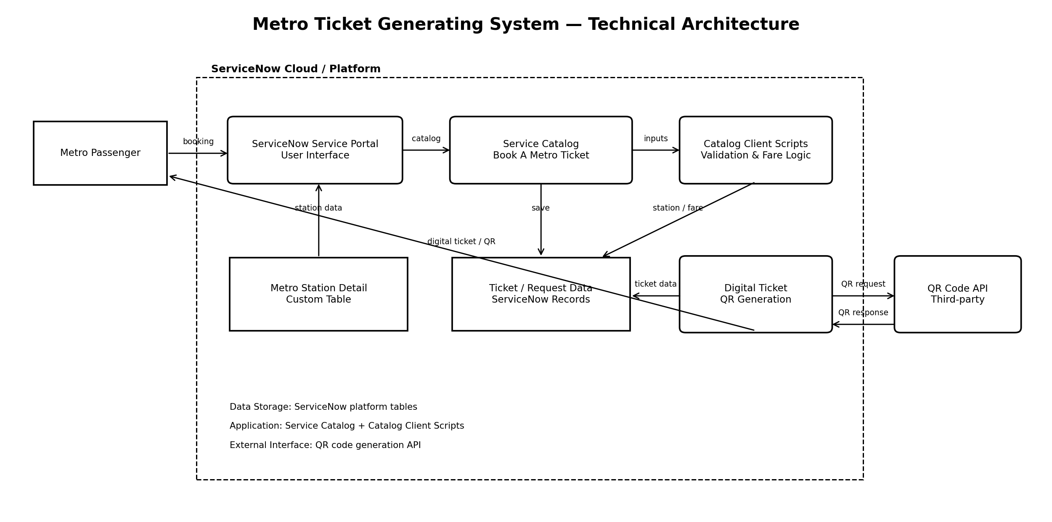
Architecture Flow
Metro Passenger → ServiceNow Service Portal → Book A Metro Ticket Catalog Item → Catalog Client Scripts → Metro Station Detail / Ticket Records → QR Generation → Digital Metro Ticket.
Table-1: Components & Technologies
S.No | Component | Description | Technology
1 | User Interface | Interface through which the passenger enters metro journey details. | ServiceNow Service Portal
2 | Application Logic-1 | Processes booking variables and validates the entered journey information. | ServiceNow Catalog Client Scripts
3 | Application Logic-2 | Calculates the fare based on source, destination, journey type and passenger count. | JavaScript in Catalog Client Script
4 | Application Logic-3 | Controls ticket submission and digital ticket/QR flow. | ServiceNow Catalog Client Script / Service Portal
5 | Database | Stores metro station information and ticket/request data. | ServiceNow platform tables / custom Metro Station Detail table
6 | Cloud Database | Cloud-hosted application data storage provided by the ServiceNow platform. | ServiceNow platform data storage
7 | File Storage | No separate file-storage service is required for the current project. | Not separately used
8 | External API-1 | Generates the QR code image for the digital metro ticket. | QR Code Generation API (api.qrserver.com)
9 | External API-2 | No second external API is required in the current implementation. | Not used
10 | Machine Learning Model | No machine learning model is required for this rule-based ticket booking system. | Not applicable
11 | Infrastructure (Server / Cloud) | Application is hosted and accessed through the ServiceNow platform. | ServiceNow Cloud Platform

Table-2: Application Characteristics
S.No | Characteristics | Description | Technology
1 | Open-Source Frameworks | The current project is primarily implemented using ServiceNow platform features and JavaScript; no separate open-source application framework is required. | JavaScript / ServiceNow platform
2 | Security | Access is controlled through the ServiceNow platform and its application access mechanisms. User inputs should be validated before submission. | ServiceNow access controls and validation
3 | Scalable Architecture | The solution uses a centralized ServiceNow platform and can be extended by adding stations, routes, variables and business logic without changing the overall user flow. | ServiceNow platform / Service Catalog
4 | Availability | The application is accessed through the ServiceNow platform, so the project does not require a separate local application server. | ServiceNow Cloud Platform
5 | Performance | Client-side validation and fare calculation provide immediate feedback when users change booking values, reducing unnecessary processing for simple calculations. | ServiceNow Catalog Client Scripts / JavaScript

Important note: The QR code API is included because the project implementation uses an external QR-code URL. No machine-learning model is used in this project. Where the template asks for a technology not used by the project, it is explicitly marked as not used rather than adding an unrelated technology.

